**Problem statement:-**

As unemployment is a burning issue in the present scenario, it is really important to understand the factors that influence the recruitment and the patterns of evolving technologies. Also we need to understand the changing trends in jobs and adopt require technical skills in order to succeed in a profession.

Analyzing the data of previously students placed may show hidden insights of the requirement for a specified job and some hidden patterns that decide the placements or packages. Knowing this may help the unemployed to understand the requirement of skill they need to develop and can cover-up the lagging areas.

So the aim of this project is to predict the possibility of a student being placed and the minimum package they may be offered based on his/her academic qualification, scores and the stream/specializations they choose. So that they may estimate their skill and can concentrate more on weaker areas. This is predictions are done by building a model using the previous placement data.

**Data-set:-**

Resource: internet

This data set has 216-rows and 15-coloumns .

The data set contains

* 10th percentage and board
* 12th percentage and board
* Degree stream and percentage
* MBA specialization and percentage
* Work experience
* Placement status
* Salary per month

**Label encoding:-**

In this data-set most of the data is of object data type, the machine learning model cant process the object data types .so a few columns are encoded using label encoder function as follows:

* gender:male=1 female=0
* 10th board: central=0 others=1
* 12th board central=0 others=1
* ug stram commerece=1 arts=0 science=2
* degree_t sci&tech=2 comm&mng=0 others=1
* mba specialisation mkt&fin=0 mkt&hr=1
* status p=1 np=0

**Proposed systems:-**

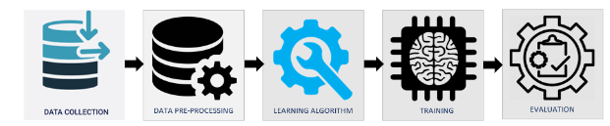

* Data source: internet
* Data Pre-Processing : dealing missing values, normalization of data, label encoding….etc
* Algorithm selection: Logistic Regression(Sklearn)
* Training model
* Getting user inputs
* Processing user data
* prediction